Thirty-Fourth Annual Fall Institute on Estate Planning


Who we are:

The Amarillo Area Estate Planning Council is an association of attorneys, bank trust officers, certified public accountants, insurance professionals, financial advisors and associated professionals. The primary goal of the AAEPC is to provide our members with the latest trends, tools, and techniques in estate planning.

Contact Us
Email: aaepc1@gmail.com
Web: www.aaepc.org

Featured Speakers
Jeff Lanza is a retired FBI Special Agent, internationally recognized keynote speaker, and leading expert on cybercrime, fraud prevention, and identity theft. During his more than 20-year career with the FBI, he investigated organized crime, cybercrime, human trafficking, and terrorism, while conducting hundreds of presentations for businesses, government agencies, financial institutions, and professional organizations. Jeff has appeared on numerous national television and radio programs, including a Netflix FBI documentary, and has lectured at prestigious institutions such as Harvard University and Princeton University. Known for combining compelling FBI stories, practical advice, and humor, Jeff equips audiences with actionable strategies to recognize today's evolving threats and better protect themselves, their organizations, and the clients they serve.
Marcus McCarty is an adjunct professor at the UMKC School of Law and a mentor at the school’s Center for Law, Entrepreneurship, and Innovation. He spent more than thirty years in private practice as a partner at Bryan Cave LLP and later Gilmore & Bell. His practice focused on tax, economic development, and public finance. After leaving private practice in 2019, he served as senior consultant to the University of Missouri System, working to promote broadband infrastructure development and deployment throughout the state. He speaks and writes regularly on the use of generative AI in business and government, broadband infrastructure expansion, and digital technology.
Jill Jester is a Shareholder of Minor &amp; Jester, P.C. in Denton, Texas, primary practicing in real estate, probate, and civil litigation. Jill earned her J.D. from South Texas College of Law in 2010 where she was on the Dean’s List and received the Order of the Barrister for her outstanding oral advocacy in national competitions. She has served as Chair of the Real Estate, Probate, Trust Law section of the Denton County Bar Association, is a Qualified Texas Mediator, and a Fellow of the College of the State Bar of Texas. Jill has been voted several times as Best Civil Lawyer and Best Wills &amp; Estate Planning Attorney in the “Best of Denton County” publication. She is a frequent speaker at legal conferences and serves on the Denton City Council.
Michael Goller is a Shareholder in Reinhart's Corporate and Tax Departments, where he served as Tax Department Chair for over ten years. He leverages his more than three decades of experience, accounting degree and strong relationships within the IRS and various State Departments of Revenue to be an especially effective lawyer. He assists clients with federal and state tax controversy, tax litigation and tax planning.
Michael's clients vary from large public corporations to mid-sized, private businesses. He's a self-described "tax geek who litigates," pairing his outgoing personality with extensive, detailed knowledge and a dedicated work ethic. He represents clients involved in complex disputes with the IRS, the U.S. Department of Justice and various other authorities and has an impressive track record of favorable settlements.
He is the co-author of Federal Tax Practice and Procedure. (CCH) Michael enjoys sharing his expertise through writing and speaking engagements on a variety of tax controversy, litigation and planning topics. He is a longtime faculty member at the University of Wisconsin-Milwaukee's Lubar School of Business and teaches Tax Practice and Procedure in the Graduate Tax Program.
Outside the office, he enjoys cooking haute cuisine, having taken cooking classes in both Italy and France. In fact, over the years, Michael has raised significant funds for a variety of charities by auctioning his services as a chef. He spends time with his wife and daughter, plays golf and loves to travel.

Schedule: Wednesday November 4th

7:30 a.m. Attendee Arrival and Check-In / Breakfast

8:00 a.m. Welcome and Introductions: Hosted by Amarillo Area Foundation

8:15 a.m. Jeff Lanza
Protecting Your Clients and Your Firm in the Age of AI:
Cybercrime, Fraud, and Financial Exploitation for Estate Planning Professionals

Cybercrime and fraud are increasingly important risk factors in the preservation of a client's
wealth, legacy, and estate. Today's criminals are leveraging artificial intelligence, advanced
social engineering tactics, and highly convincing impersonation schemes to deceive individuals
and jeopardize their financial security. In this presentation, retired FBI Special Agent Jeff Lanza
shares true stories, emerging fraud trends, and practical strategies that estate planning
professionals can use to better protect both their clients and their own organizations.
Attendees will learn how today's scams operate, recognize warning signs of financial
exploitation and AI-enabled fraud, and identify practical steps that can help reduce risk while
protecting themselves, their practices, and their clients.

10:15 a.m. -15-minute Break

10:30 a.m. Marcus McCarty
The Ethical Use of Generative AI: A Practical Guide for the Estate Planning Practice

In just three years, generative AI has moved from novelty to fixture in many law practices.
Today, generative AI and related tools are substantially more capable — and far more deeply
connected to firm email, document management, and client files — than the chatbots most
lawyers first encountered. This presentation will highlight the ethical duties governing the use of
this new technology. Topics will include the Texas Disciplinary Rules and Professional Ethics
Committee Opinion 705, ABA Formal Opinion 512, and recent guidance from the IRS Office of
Professional Responsibility. The presentation also will include practical ideas for using
generative AI in an estate planning practice, including model selection and setup, education and
procedures regarding its use by attorneys and staff, verification practices and procedures, and
specific steps needed to preserve client confidentiality.

11:30 a.m. Lunch

12:30 p.m. Jill Lester
Bloodlines and Battlefields – Partition Suits in Heirship Proceedings

Increasingly more common with real estate values rising, learn the legal framework governing partition actions arising in the heirship context, where indivisible estate assets—particularly real property—must be equitably divided among heirs holding property as tenants in common. We will cover the statutory bases for partition; the distinction between partition in kind and partition by sale; the Texas Uniform Partition of Heirs Property Act and its safeguards; and procedural requirements.

1:30 p.m. 15-minute Break

1:45 p.m. Michael Goller
Hot Tax Practice and Procedure and Ethics Issues for the Estate Planner
This engaging program will address timely tax practice, procedure, and ethics issues that estate-planning professionals and other tax advisers should know. The presentation will provide practical updates on current IRS and state tax examination and enforcement developments, important procedural and deadline traps, professional-responsibility and Circular 230 concerns, valuation and appraisal issues, and other recurring problems arising in audits, appeals, and tax planning. Particular attention will be given to common blunders practitioners should avoid, strategies for responding effectively to government information requests, preserving a strong administrative record, and applying sound professional judgment in a changing tax-enforcement environment.

3:45 p.m. - Survey Participation Gift Card Drawing!

End of Day

General Information
Location - The program will be held at the Amarillo National Bank Skyline Room:
410 S. Taylor, 16th floor
Amarillo, TX 79101
Tuition/Registration – Tuition includes admission to the morning and afternoon session, continental breakfast, catered luncheon, and refreshments at the breaks.
**REGISTRATION FEES MUST BE RECEIVED PRIOR TO THE EVENT TO RECEIVE CE. **
Cancellation and Refund Policy – Tuition will be refunded upon written cancellation received not later than October 26, 2026. Cancellations received after October 26, 2026, cannot be refunded. No refunds for no-shows.
Early Registration - Early registration is encouraged. Should seating become limited, priority will be given to AAEPC members and nonmembers will be accommodated on a first come, first served basis. Please register by October 26, 2026.
CLE/CE Credit - Accreditation for this institute has been requested but is subject to approval from: the State Bar of Texas; Texas State Board of Public Accountancy; Certified Financial Planners; and American Bankers Association for (CTFA and CRSP). Please see the bottom of our event page for CE that has been approved.
Program Materials – Each paid attendee will be able to access the speaker’s material, if any is provided, online.
Course Objective – These practical courses are designed to teach participants various tax and non-tax related issues that are involved in advising estate planning clients, and how to effectively resolve client concerns and meet the best needs of the client, including utilizing insurance to achieve the client’s goals. Participants should have a basic or beginning understanding of relevant tax concepts and principles of estate planning.

We would like to thank our generous sponsors:


Platinum




Gold

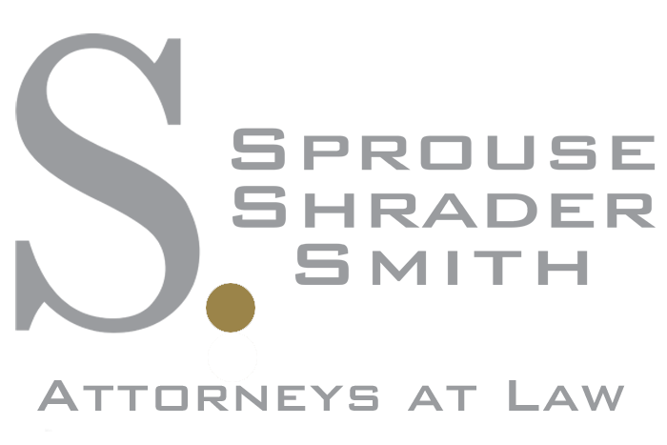


Silver



