Thirty-Fourth Annual Spring Institute on Estate Planning


Who we are

The Amarillo Area Estate Planning Council is an association of attorneys, bank trust officers, certified public accountants, insurance professionals, financial advisors and associated professionals. The primary goal of the AAEPC is to provide our members with the latest trends, tools, and techniques in estate planning.

Contact Us
Email: aaepc1@gmail.com
Web: www.aaepc.org

Featured Speakers

Joyce Marter, LCPC, CSP is an internationally recognized keynote speaker, licensed psychotherapist, and award-winning author of The Financial Mindset Fix: A Mental Fitness Program for an Abundant Life. Known as “America’s Workplace Therapist,” Joyce helps individuals, families, and organizations thrive mentally, emotionally, and financially.
With over 25 years of experience, Joyce has spoken for hundreds of organizations including financial institutions, professional associations, corporations, and universities. Her work bridges psychology, behavioral finance, and leadership—helping professionals better understand the human side of money, decision-making, and legacy planning. Joyce is a Certified Speaking Professional (CSP), a Forbes contributor, and a frequent media expert on mental health and financial well-being.

Bradley Burnett, J.D., LL.M. is a practicing Colorado tax attorney with 41 years of tax practice experience. His practice emphasis is on tax planning and tax controversy resolution. He has served as adjunct professor at the University of Denver School of Law Graduate Tax Program. He has delivered more than 3,800 live, in-person presentations on U.S. tax law and authored texts of 48 CPE and CLE courses. He has authored and been lead instructor for CCH’s Federal Tax Update course for nine consecutive years, presented at AICPA’s Engage national convention and been quoted in Tax Notes Today in a feature article on S Corp shareholder basis. His seminar style is to deliver the subject matter in briskly paced, enthusiastic and witty fashion. His forte’ is the candid communication of practical ideas relating to tax law.

Brian Hickey has over 29 years of experience in the insurance industry, I currently serve as Vice President at Insuractive, overseeing the company’s P&L, strategic initiatives, and operational management. My work focuses on empowering consumers and advisors by delivering effective solutions in Medicare, life insurance, and wealth protection through our consumer and advisor brands, including Medicare BackOffice, Medicare MarketPlace, Travel Insurance Center and Alliant Medicare Solutions.

R. Shaun Rainey is an attorney in Midland, Texas, serving as a shareholder and Section Head of the Estate Planning and Probate practice at Cotton Bledsoe Tighe & Dawson. Board Certified in Estate Planning and Probate Law by the Texas Board of Legal Specialization and a Fellow of the American College of Trust and Estate Counsel, he focuses on sophisticated estate planning, probate, fiduciary litigation, and asset protection. His work includes designing complex estate plans, drafting revocable and irrevocable trusts, advising family offices and private foundations, and handling both contested and uncontested probate matters, including first-chair jury trials. He is licensed in Texas, New Mexico, and multiple federal courts, including the United States Tax Court.
Mr. Rainey earned his Juris Doctor, cum laude, from Texas Tech University School of Law, where he served as Student Bar Association President and Vice-Chair for Trial Advocacy, and competed on the national mock trial team. He received his undergraduate degree from Rice University, where he was a varsity football player and Scholar Athlete. He is also an author, speaker, and adjunct professor, contributing to TexasBarCLE programs and publications, and remains active in professional and community leadership roles, including service with local civic and nonprofit organizations.

Darlene Payne Smith is a member of her firm’s Fiduciary Litigation and Probate, Trust, and Guardianship groups. Her practice focuses on representing fiduciaries and beneficiaries in probate, guardianship, and trust litigation, including disputes involving incapacity and contested estate matters. She is also an experienced mediator and a frequent writer and speaker for continuing legal education programs.
Darlene holds a B.S. magna cum laude from the University of Houston and a J.D. from the University of Houston Law Center. She is an adjunct professor at South Texas College of Law and co-author of the Texas Jury Charge for Probate and Trust. Her honors include Texas Super Lawyers, Best Lawyers in America for Litigation—Trusts and Estates, and Texas Trailblazer recognition.

Schedule

Wednesday May 6, 2026

7:30 a.m. Attendee Arrival and Check-In

Breakfast -

8:00 a.m. Welcome and Introductions

8:15 a.m. Joyce Marter, LCPC, CSP: The Financial Mindset Fix for Estate Planning Professionals
Estate planning is rarely just about documents, numbers, or tax strategy—it’s about human behavior, emotional decision-making, family dynamics, and deeply held money beliefs. Even the most technically sound plans can fall apart when fear, avoidance, conflict, or scarcity thinking go unaddressed.
In The Financial Mindset Fix, internationally recognized psychotherapist and financial mindset expert Joyce Marter explores the psychology that drives how individuals and families make financial decisions, plan for the future, and navigate wealth transfer. Drawing from behavioral finance, clinical psychology, and her work with high-performing professionals and organizations, Joyce reveals how unconscious money beliefs impact client behavior, communication, and long-term outcomes.
This engaging and practical session helps estate planning professionals better understand the emotional drivers behind client resistance, indecision, family conflict, and legacy concerns—while offering tools to foster clearer conversations, stronger trust, and more sustainable planning outcomes.

10:15a.m. – Break

10:30 a.m. - Bradley Burnett, J.D., LL.M.: Utilizing Generative Artificial Intelligence in Tax and Estate Planning Practice Hands-On Skill Sets for Success
Generative artificial intelligence (GAI) has taken tax and estate planning practice by storm. Blink your eyes and it will change (and likely get a lot better very quickly). If practitioners do not jump on the GAI train now, they’re likely to get left at the station. This session focuses on skill sets needed to capably employ GAI in practice and keep from getting your head handed to you in the process. This session provides approaches, checklists and case studies of GAI search techniques and practices.

12:30p.m. – 1:30 p.m. – Lunch

1:30p.m. - Brian Hickey: Managing Healthcare Expenses In Retirement: What Baby Boomers Need to Know About Medicare and Long-Term Care
This presentation explains why enrolling in Medicare on time and making informed coverage decisions are critical to protecting your health and finances in retirement. Overall, this presentation emphasizes the importance of timely enrollment, selecting appropriate supplemental coverage, and proactively planning for rising health care expenses to ensure financial security and access to care in retirement.

2:30 p.m. – Break

2:40 p.m. - R. Shaun Rainey: “Navigating Sudden Death: A Roadmap for Guiding Clients Through Unexpected Loss”
This program is designed to help attorneys with additional considerations and concerns in representing a client through unexpected loss and the unique role we can play as advisor and counselor during these difficult times.

3:40 p.m. – Break

3:50 p.m. - Darlene Payne Smith: Estates, Trusts, Mental Commitments, and Guardianships: Dealing with Firearms
Not all estate planners give thought to firearms in the planning process, any more than they do a detailed inventory of your tools. Much improvement is needed in the education of attorneys to inquire about firearms, firearm supplies, and NFA firearms. Once a person possessing firearms dies, with or without a Will, firearms can be a problem. Are firearms a consideration in the Will? Is there a Gun Trust, fully funded and appropriately drafted? If, does the Decedent own an NFA firearm such as a silencer? Will a Court appointed administrator sell firearms that the Decedent treasured to a stranger? Will anyone know where the Decedent would have left his firearms? Trusts created during life (intervivos) or at death (testamentary) come with their own protections and problems. Finally, mental issues, incapacity, invoking the use of powers of attorney and guardianship, which a large focus of this article, may deprive the incapacitated of all firearms and ammunition, as well as hamper the lives of those with whom the incapacitated resides.

4:50 p.m. – 5:30 p.m. – Upcoming Events, Gift Card Raffle, and Happy Hour
End of Day

General Information
Location - The program will be held at the Amarillo Club: 600 S. Tyler St, Amarillo, TX 7910-Floor 31
Tuition/Registration – Tuition includes admission to the morning and afternoon session, continental breakfast, catered luncheon, and refreshments at the breaks.
Cancellation and Refund Policy – Tuition will be refunded upon written cancellation received not later than April 29, 2026. Cancellations received after April 29, 2026, cannot be refunded. No refunds for no-shows.
Early Registration - Early registration is encouraged. Should seating become limited, priority will be given to AAEPC members and nonmembers will be accommodated on a first come, first served basis. Must register by April 29, 2026.
CLE/CE Credit - Accreditation for this institute has been requested but is subject to approval from: the State Bar of Texas; Texas State Board of Public Accountancy; Certified Financial Planners; and American Bankers Association for (CTFA and CRSP). Please see the bottom of our event page for CE that has been approved.
Program Materials – Each paid attendee will be able to access the speaker’s material, if any is provided, online.
Course Objective – These practical courses are designed to teach participants various tax and non-tax related issues that are involved in advising estate planning clients, and how to effectively resolve client concerns and meet the best needs of the client, including utilizing insurance to achieve the client’s goals. Participants should have a basic or beginning understanding of relevant tax concepts and principles of estate planning. NO PRE-REQUISITES ARE REQUIRED.

We would like to thank our generous sponsors:

Platinum




Gold



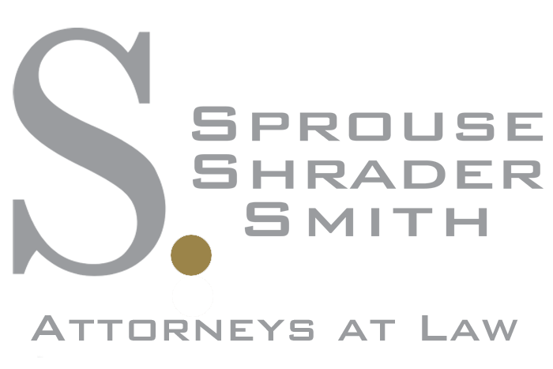



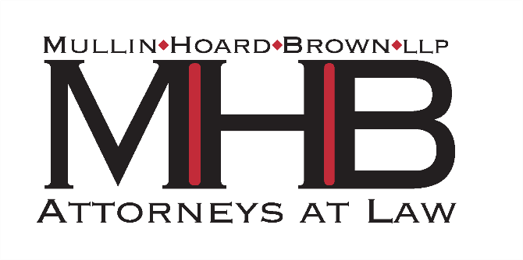
Silver

