# **Thirty-Third Annual Fall Institute on Estate Planning**



## **Who we are:**

## The Amarillo Area Estate Planning Council is an association of attorneys, bank trust officers, certified public accountants, insurance professionals, financial advisors and associated professionals. The primary goal of the AAEPC is to provide our members with the latest trends, tools, and techniques in estate planning.

## Contact Us

Email: [aaepc1@gmail.com](mailto:aaepc1@gmail.com)

Web: [www.aaepc.org](http://www.aaepc.org)

# **Featured Speakers**

**Dr. Ray Perryman** is President and CEO of The Perryman Group, a Waco-based economic research firm. With a BS in Mathematics from Baylor and a PhD in Economics from Rice, his accidental entry into economics began with a coin flip. He has held academic posts at Baylor, SMU, and other institutions, authored over 400 academic papers and several books, and served as president of key regional economic associations. He’s been called a “genius” by *The Wall Street Journal*, “the most quoted man in Texas” by *Texas Monthly*, and “the state’s premiere barbecue connoisseur” by *The Dallas Morning News*.

Dr. Perryman’s firm has conducted thousands of major economic studies for clients ranging from Fortune 100 companies to government agencies. A prolific writer and speaker, he also engages in substantial pro bono work addressing poverty, hunger, and health care. Among hundreds of accolades, he’s received the Texan of the Year award, numerous lifetime achievement honors, and even been nominated for the Nobel Memorial Prize in Economics. Despite a packed professional life, he finds humor in the everyday—once crashing one of his cars into another—and proudly serves as an honorary Kilgore Rangerette (though not yet on the traveling squad).

**Russel James** Russell James, J.D., Ph.D., CFP® is a professor in the School of Financial Planning at Texas Tech University where he directs the graduate program in Charitable Financial Planning (planned giving). He graduated, *cum laude*, from the University of Missouri School of Law where he was a member of the Missouri Law Review and received the United Missouri Bank Award for Most Outstanding Work in Gift and Estate Taxation and Planning. He also holds a Ph.D. in consumer economics from the University of Missouri, where his dissertation was on charitable giving. He is a member of the National Association of Charitable Gift Planners (CGP) Hall of Fame and an Honorary Fellow of the American College of Trust and Estates Counsel (ACTEC).

**Julia Jonas** is board certified in Estate Planning and Probate Law by the Texas Board of Legal Specialization. Julia works with clients on their estate planning, including wills, trusts, partnerships, and other types of gifting.  She enjoys working with individuals and families of all backgrounds to find the right structure to address their specific needs, such as guardianship for minor children, custom trust provisions, estate and generation-skipping transfer tax planning, family business issues, and unique assets. Julia practices law with her father, Glenn Karisch.

**Joel Crouch** counsels and advises businesses, wealthy individuals and families about their most demanding tax planning, estate planning and IRS controversies.  He often works with tax professionals and financial specialists to help develop solutions for their clients. Joel is a Partner in the firm and is Board Certified in Tax Law by the Texas Board of Legal Specialization. Joel has been recognized as one of the best in his field by Texas Monthly and Law and Politics magazines by being named a Texas Super Lawyer from 2003 through 2025. Mr. Crouch has been selected to the Top 100: Dallas/Fort Worth Texas Super Lawyers list for the primary practice area of Tax Law in 2020 and 2024.  He has also been named one of the Best Lawyers in Dallas by D Magazine for the years 2012-2025. Mr. Crouch has been recognized by Best Lawyers in America® in Tax Law for the years 2015-2025.  Mr. Crouch was named the Best Lawyers 2022® Tax Law "Lawyer of the Year" in Dallas/Ft. Worth. Mr. Crouch has been ranked in the 2024 and 2025 Chambers and Partners USA Legal Guide in the Tax Litigation practice area.

**Rory Sheppard** is a senior executive with over 30 years of leadership experience across some of Texas’s most iconic brands, including Hastings Books & Records, Builders Square, AT&T, H-E-B, and Whataburger. His career has been largely rooted in large, complex, family-owned businesses—giving him valuable insight into the unique needs of family ownership groups, especially those with strong community and philanthropic commitments.

Rory has successfully led large, cross-functional teams across areas such as Information Technology, Finance, Customer Service, Internal Consulting, and Strategy. Known as a powerhouse executive and trusted leader in both the corporate and nonprofit sectors, he brings bold, real-world expertise and practical insight to every keynote and breakout session he delivers.

Whether you're leading a large corporation, your family business, or a community organization, Rory understands the desire for simple, actionable practices to live with purpose, lead with courage, and leave a legacy of faith and impact.

# **Schedule**

## Wednesday November 5th

## **7:30 a.m. Attendee Arrival and Check-In / Breakfast -**

## **7:50 a.m. Welcome and Introductions**

**Hosted by Amarillo Area Foundation**

**8:00 a.m. Dr. Ray Perryman**

**The Economic Outlook for Texas: Key Patterns and Forces Shaping Future Growth**

Dr. Perryman will discuss his latest outlook for the Texas economy. An overview of US and global conditions will be included, as well as a description of how these national and international forces are affecting expansion prospects for the state. Key sources of potential growth and challenges to be dealt with will also be described. Topics will include, among others, tariffs and trade policy, energy and the future of oil and gas, demographic changes, and emerging industries.

**9:00 a.m. Russell James, J.D., Ph.D., CFP®**

**Special charitable financial planning opportunities for 2025**

Market fluctuations, interest rate changes, SECURE & SECURE 2.0, other new legislation — the changes never seem to stop! But with change comes opportunity. This combination of circumstances has led to some attractive opportunities for donors and clients with charitable interests. In this presentation, Dr. James reviews the strategies available to help clients take advantage of these special opportunities. Additionally, he will share his latest decision-making research results revealing the words, phrases and conversation strategies that are most effective in communicating with donors during times like these.

**11:00 a.m.**  **Buffet line opens for lunch**

**11:30 a.m. Lunch Presentation: Julia Jonas, Karisch Jonas Law**

**The 2025 Texas Estate and Trust Legislative Update:**

This course provides a detailed statutory update from the 2025 Texas legislative session, focusing on changes to the Texas Estates Code, Texas Trust Code (Texas Property Code), and related statutory provisions. Topics include updates affecting decedents’ estates, probate proceedings, guardianships, powers of attorney, trusts, and fiduciary duties. Participants will gain a clear understanding of how the 2025 legislative changes impact estate planning, administration, and capacity-related legal tools in Texas. The course is designed for attorneys, fiduciaries, and financial professionals who need to stay current on Texas law affecting estate and incapacity planning.

**12:30 p.m. Joel N. Crouch, J.D. Partner, Meadows Collier Reed Cousins Crouch &**

**Ungerman, LLP**

**Even with Higher Exemptions, the IRS is Not Giving Up on Estate and Gift Tax Examinations**

Despite historically high exemption amounts for estate and gift taxes, the IRS continues to actively pursue examinations in this area. This course provides a timely and practical overview of the IRS's current enforcement initiatives, audit strategies, and legal challenges in the estate and gift tax arena. Participants will gain insights into key issues that the IRS is targeting in examinations, including valuation disputes, use of discounts, and reporting inconsistencies.

The presentation will also analyze recent court decisions that shape estate and gift tax planning, offering participants actionable guidance to mitigate audit risks and stay compliant in a shifting regulatory environment.

Led by Joel N. Crouch, a nationally respected tax attorney, this course provides essential insights for legal and financial professionals involved in estate planning and wealth transfer strategies.

**1:30 p.m. Break (15-minutes)**

**1:45 p.m. Rory Sheppard, ActionCOACH of West Texas**

**What Your Client’s Business is Worth:Knowing the value is critical for everything from key-person insurance to estate planning.**

Every business owner needs to know the value of their business – and we want them to

ensure that they have a transition plan to the next generation, to passive income with a

leadership team in place, or a wealth-creation event through the sale of the business.

90%+ of all businesses in the United States are privately held. These businesses are

responsible for both employing & paying salaries for more than 60% of the US population.

When a business owner knows the value of the business, they can more effectively plan for

their future – and estate planning professionals.

**2:45 p.m. Rory Sheppard, ActionCOACH of West Texas**

**Making the Most of Difficult Conversations**

Improving communication and empathy skills through the use of the platform of Emotional Intelligence and techniques from leading experts.

**3:45 p.m. - Survey Participation Gift Card Drawing!**

**End of Day**

**General Information**

**Location -** The program will be held at the Amarillo Area Foundation, 919 S Polk St, Amarillo, TX 79101

**Tuition/Registration –** Tuition includes admission to the morning and afternoon session, continental breakfast, catered luncheon, and refreshments at the breaks.

**\*\*REGISTRATION FEES MUST BE RECEIVED PRIOR TO THE EVENT TO RECEIVE CE. \*\***

**Cancellation and Refund Policy –** Tuition will be refunded upon written cancellation received not later than October 29, 2025. Cancellations received after October 29, 2025, cannot be refunded**. No refunds for no-shows.**

**Early Registration** - Early registration is encouraged. Should seating become limited, priority will be given to AAEPC members and nonmembers will be accommodated on a first come, first served basis. **Please register by October 29, 2025.**

**CLE/CE Credit -** Accreditation for this institute has been requested but is subject to approval from: the State Bar of Texas; Texas State Board of Public Accountancy; Certified Financial Planners; and American Bankers Association for (CTFA and CRSP). Please see the bottom of our event page for CE that has been approved.

**Program Materials –** Each paid attendee will be able to access the speaker’s material, if any is provided, online.

**Course Objective –** These practical courses are designed to teach participants various tax and non-tax related issues that are involved in advising estate planning clients, and how to effectively resolve client concerns and meet the best needs of the client, including utilizing insurance to achieve the client’s goals. Participants should have a basic or beginning understanding of relevant tax concepts and principles of estate planning.

**We would like to thank our generous sponsors:**

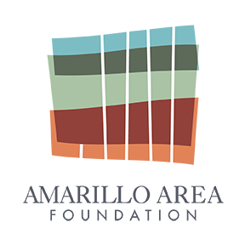**Platinum**



**Gold**



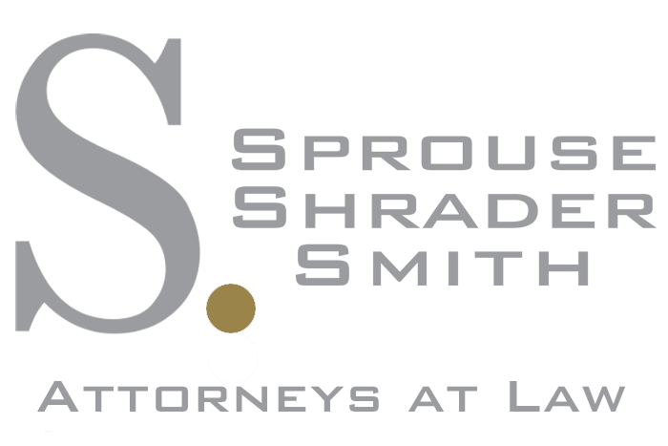

**Silver**