*We would like to thank our generous sponsors*

**Platinum Sponsor**

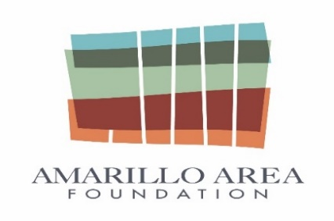

**Amarillo Area Foundation**

*We would like to thank our generous sponsors*

**GOLD SPONSOR**

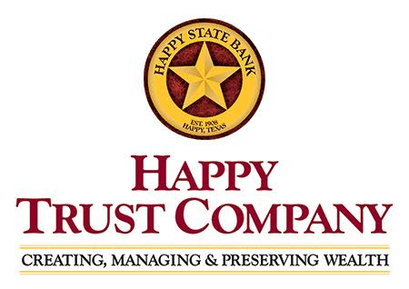

|  |  |
| --- | --- |
| **Amarillo National Bank** |  |
| **FirstBank Southwest** |  | |
| **Happy State Bank**  *We would like to thank our generous sponsors*  **Silver Sponsor**    **Burdett Morgan Williamson &Boykin**    **Sprouse Shrader Smith, PLLC** | | |



**Mullin Hoard & Brown LLP**